PARAMETERIZED CONSTRUCTOR

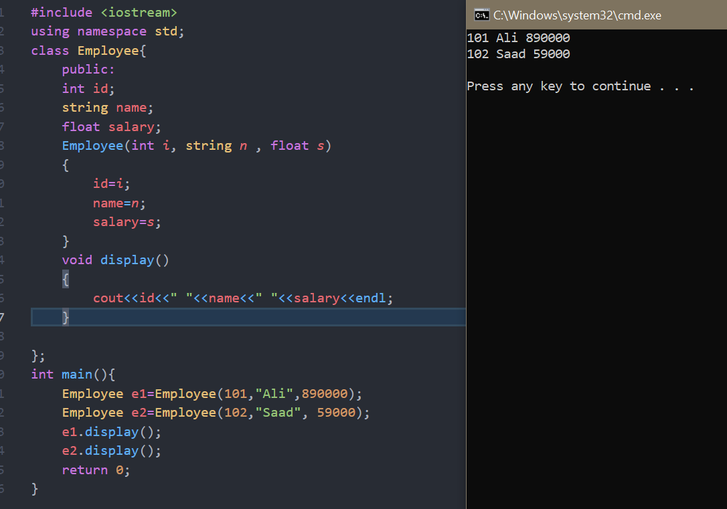

PARAMETERIZED CONSTRUCTOR EXAMPLE 2

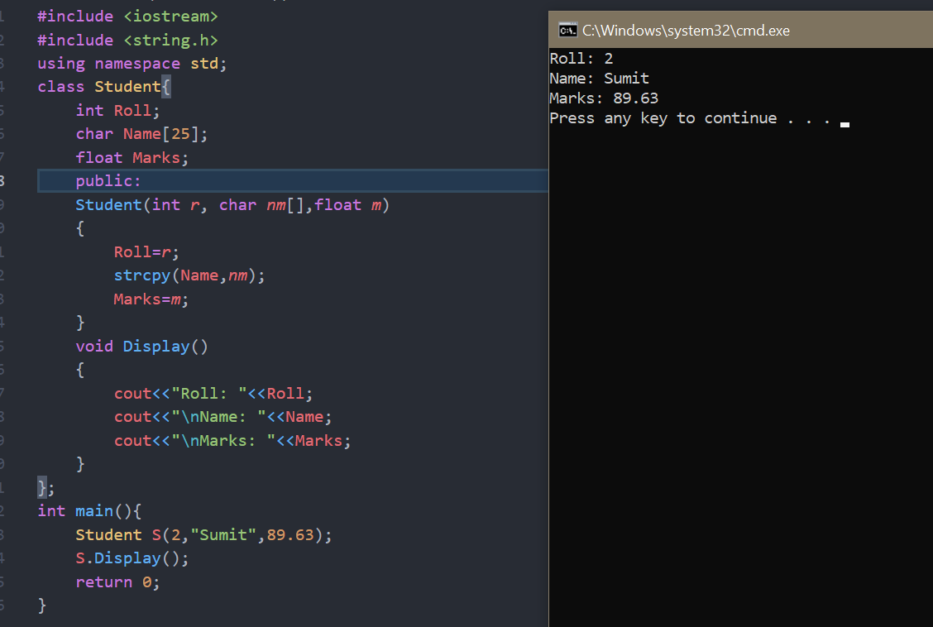

DEFAULT COPY CONSTRUCTOR

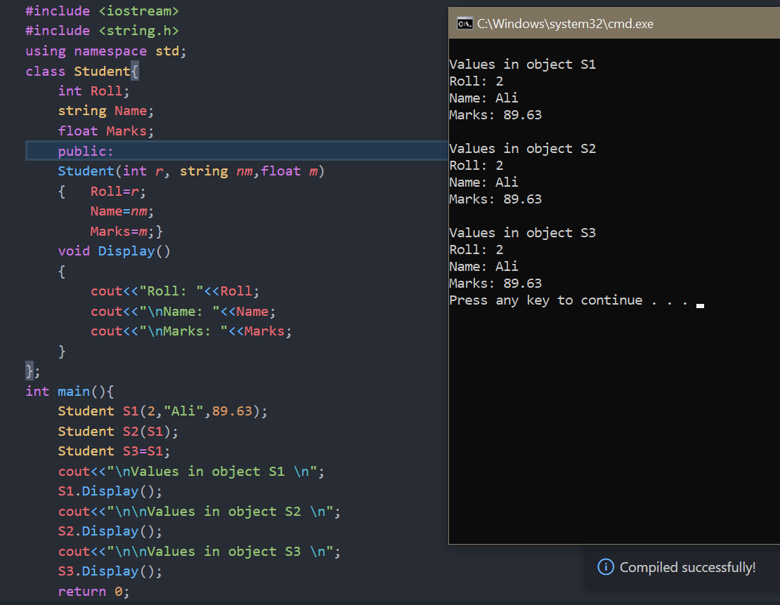

CONSTRUCTOR OVERLOADING

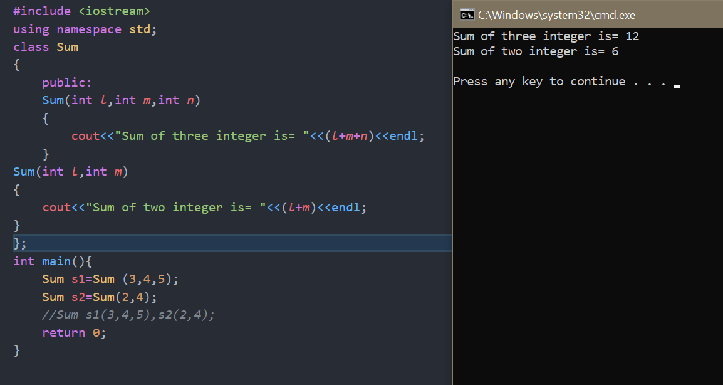

CONSTRUCTOR OVERLOADING EXAMPE 2

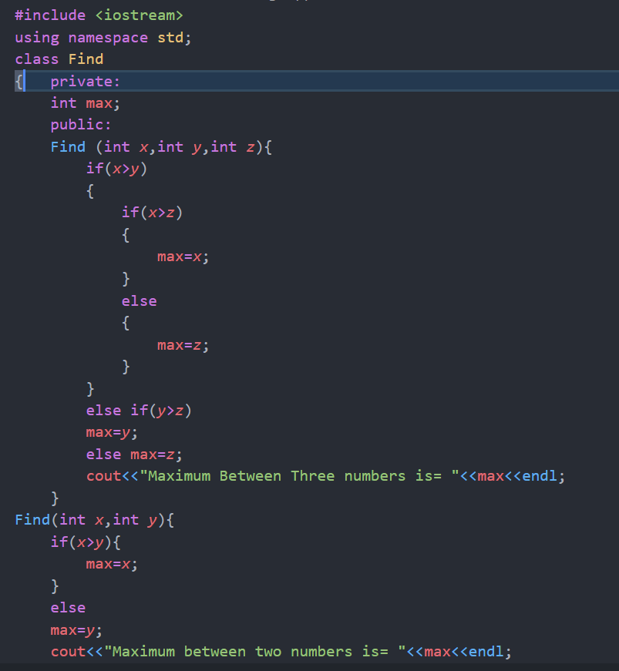

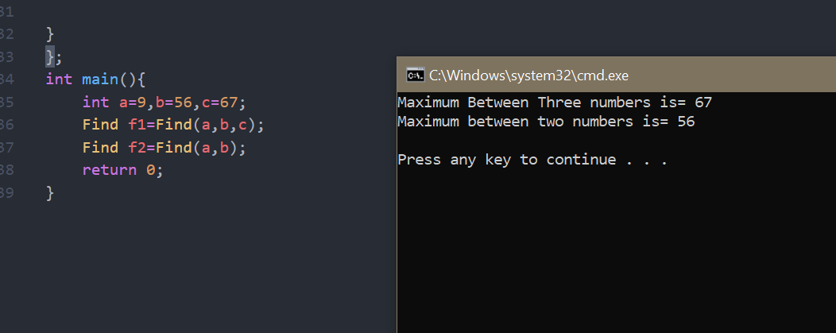

CONSTRUCTOR OUTSIDE CLASS

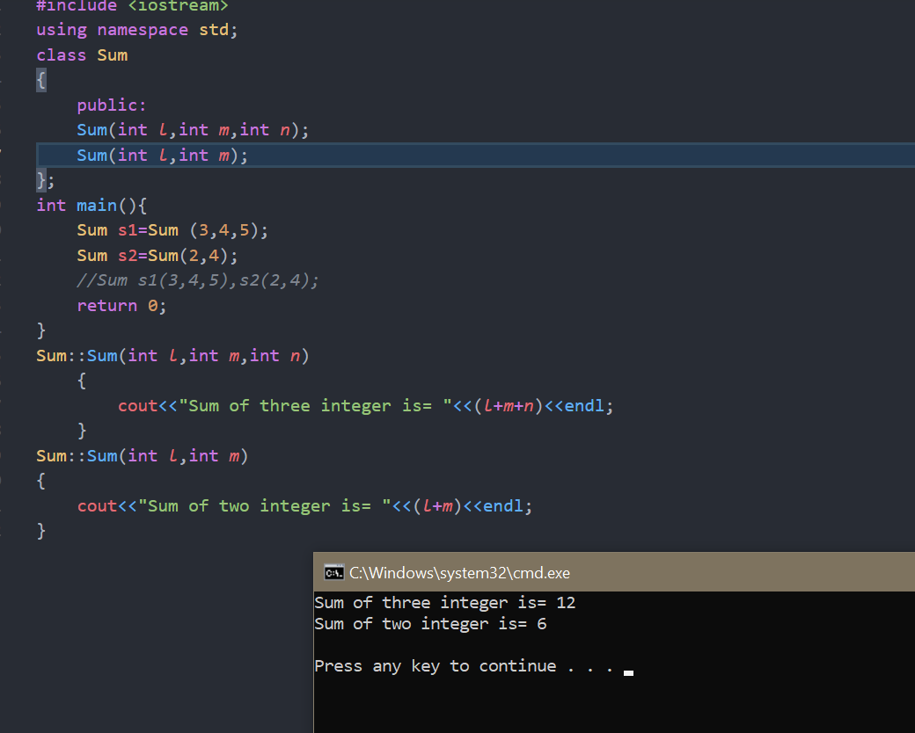

DESTRUCTOR FUNCTION

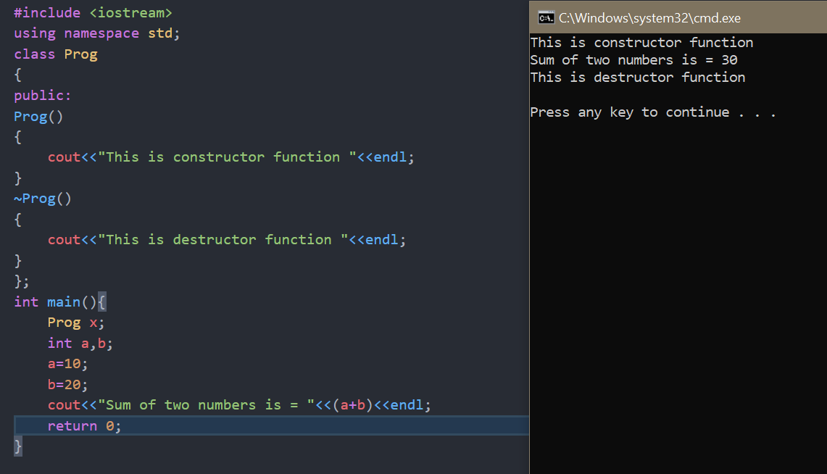

PASS OBJECT TO FUNCTION

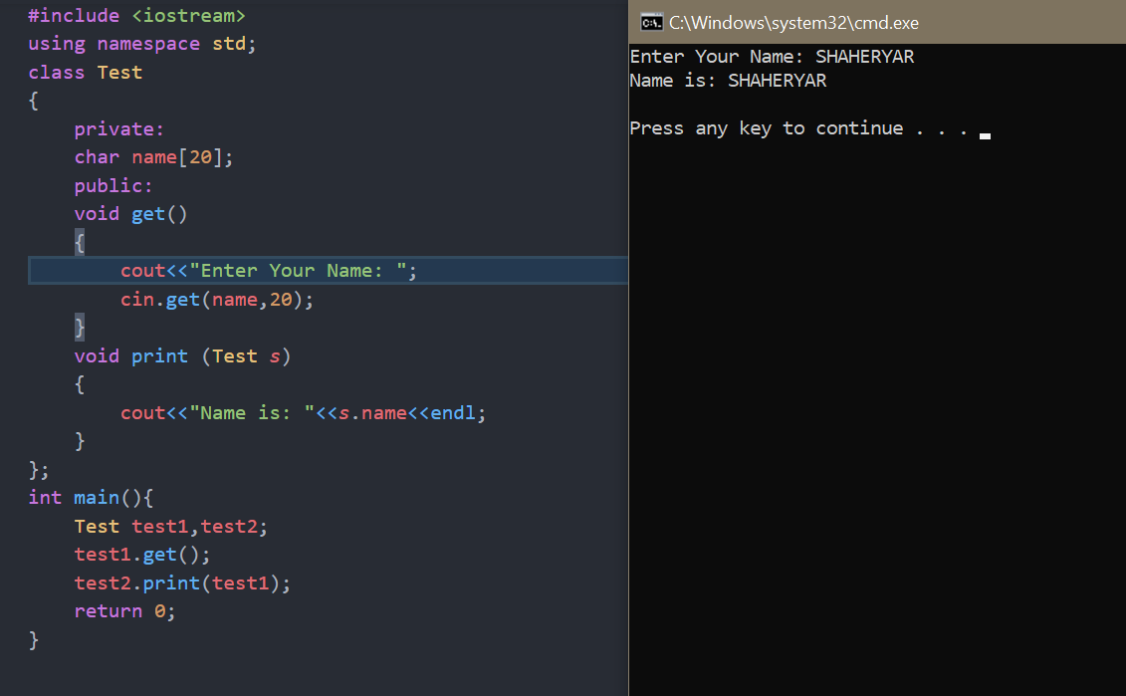

PASS OBJECT TO FUNCTION EXAMPLE 2

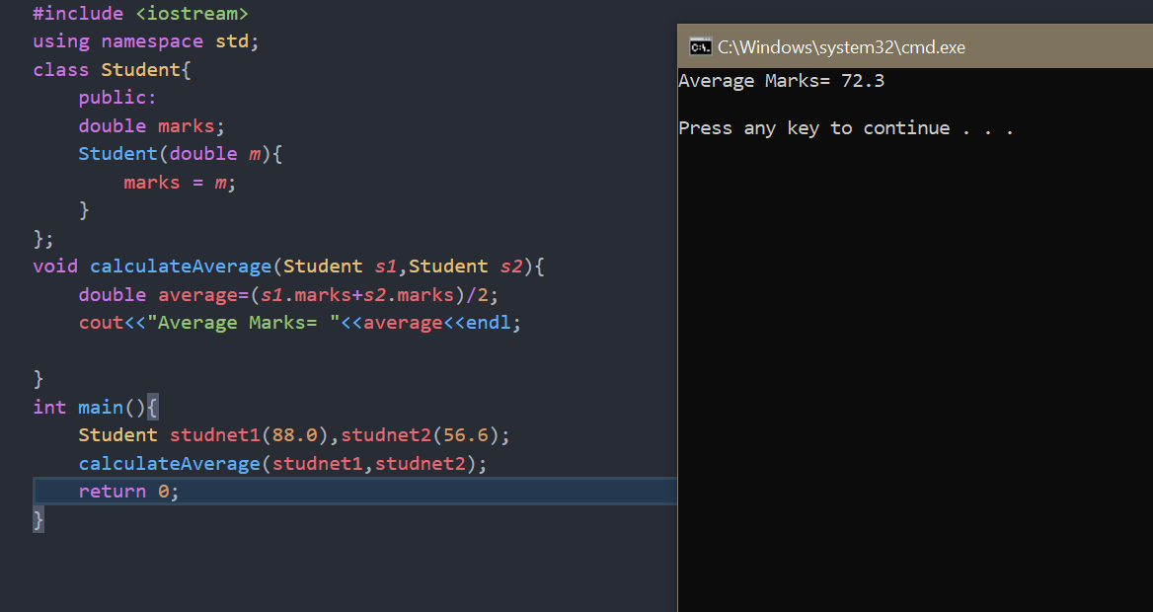

RETURN OBJECT FROM FUNCTION

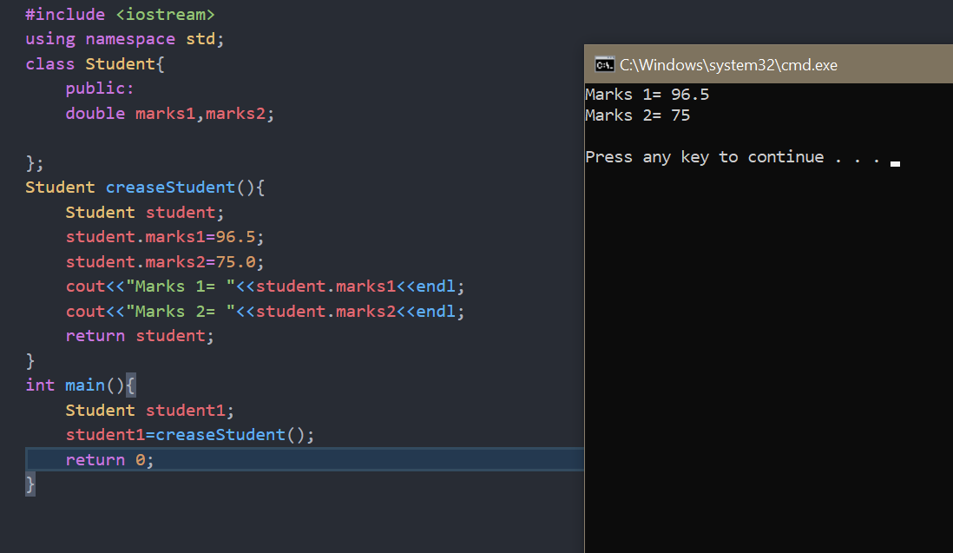

ARRAY AS CLASS MEMBER

